

**Recipes For Life:**

***Bringing the tradition of cookbooks to the 21st Century***

**Degree Show Guide Book**

**By Kari McMahon**

**AC40001 Honours Project**

**BSc (Hons) Applied Computing**

**University of Dundee 2015**

**Supervisor: Dr Keith Edwards**



**Project Background**

**What is Recipes for Life?**

Recipes For Life is an Android application that aims to bring the tradition of recipe books to the 21st century through collaborative recipe management.

**What was the motivation for the application?**

For generations collaborative cookbooks and recipes have been a way for individuals to express themselves and share experiences and traditions with others through the format of cooking. But as society increasingly moves more and more into a digital age the concept of collaborative cookbooks could soon be lost in the onslaught of digital information if it is not brought into the 21st century.

AllRecipes.com, a popular recipe website, found in the past 15 years the use of cooking websites has surged 207% with 44% of cooks preferring to use cooking websites over the 19% who prefer to use traditional cookbooks. They recognised that social referrals from tablet devices to their website increased by 787% from 2012 to 2013. It is clear that technology is becoming one of the top cooking resources available today with the tablet now beginning to replace the traditional cookbook.

Collaborative cookbooks have been seen to have many benefits but currently there are no applications on the market that offer collaborative recipe management. Recipes For Life is an Android application that aims to fit this gap in the market and presents a solution that aims to bring the tradition of recipe books to the 21st century through collaborative recipe management.

**How was the application developed?**

Recipes For Life is developed to work online and offline using a sync functionality between a central server database and the phones database. This enables the user to retrieve recipes from the app even when there is no wifi available. This is useful in many situations, an example scenario is when the user is in the supermarket and is looking for recipe ingredients. The user can still access these ingredients even if there is no wifi in the store. When there is wifi the application updates with new recipes, cookbooks etc as well as changes made by other users which enables collaboration.

Recipes For Life aims to be a market led product and was developed using a user centred design approach receiving feedback from surveys, focus groups and user testing sessions.

**Who is the intended audience?**

The intended audience is:

* Any age and gender
* Has an interest in cooking
* Competent with technology
* Has experience with cooking apps or using smartphone / tablet to aid cooking in the kitchen.
* Has experience with technology in the kitchen e.g. digital scales, timers
* Often uses online recipe websites or enjoys finding recipes through social sites such as pinterest.

On the following pages are a few personas which represent various segments of the intended audience.

**Example Persona: Frank Francis**

**Age:** 51

**Gender:** Male

**Occupation:** Owns a fruit and veg store.

**Marital status:** Married

**Interests:** bowls, working at his allotment, reading the newspaper

**Technological devices:** Uses work computer for work and has recently started using a tablet he got given for Christmas.

**Favourite websites/apps:** bbc sport, bbc good food

**Technological usage:** 4+ hours a day

**Motivation for using the application**: Frank is interested in gaining customers as well as maintaining his current customer base. Since he started working with the tablet he got given for Christmas he is interested in using social media to do this. Frank plans on having a fruit and veg package that he sells every week and recipes which go along with it. He wants to store the recipes in an area online and share these to social media outlets in hopes that customers will see these recipes and come into his store to get the ingredients. Recipes For Life enables him to store the recipes and share them on the application as well as to other social media outlets.

**Example Persona: Jimmy Doherty**

**Age:** 34

**Gender:** Male

**Occupation:** Owns a chain of 5 small Italian restaurants.

**Marital status:** engaged

**Interests:** cooking, hiking and watching football

**Technological device:** Uses laptop in work and likes to use his tablet device when chilling out in the evening.

**Favourite websites/apps:** facebook, twitter and bbc news

**Technological usage:** 6+ hours a day

**Motivation for using the application:** Jimmy owns a chain of 5 small Italian restaurants in the Glasgow area. Jimmy is always encouraging chefs to come up with new recipes and ideas for the restaurant to keep it fresh. Recipes for life would be perfect for him as he could have several cookbooks – mains, starters, drinks where his teams across the 5 restaurants could contribute recipes within. It would be a great way to find new recipes for the restaurant. They could also open some cookbooks for the public so frequent customers could cook some of their favourites at home and new customers could be gained through finding these recipes.

# How did users respond to the application?

Once development was complete the final product was evaluated against a popular recipe management application which has had over 50,000 downloads. The evaluation was to help the student understand if Recipes For Life could compete on the market against current applications.

10 participants from the ages 18 to 59 took part in the evaluation. They were asked to follow tasks laid out in a task sheet in each of the applications. They then filled out a SUS for each application. The SUS is the System Usability Scale which is a quick and reliable way to measure a products usability. The participants then were asked a few questions about each application and their preference.

The results from the evaluation were:

* All 10 participants preferred Recipes For Life
* The collaboration feature received very positive comments from participants
* Recipes For Life received an A grade in usability in the SUS evaluation.

# User Guide

The following pages will walk the user through the various screens in the application.

# Application Front Page

The first screen which is displayed to the user handles the signing in and signing up of the user.

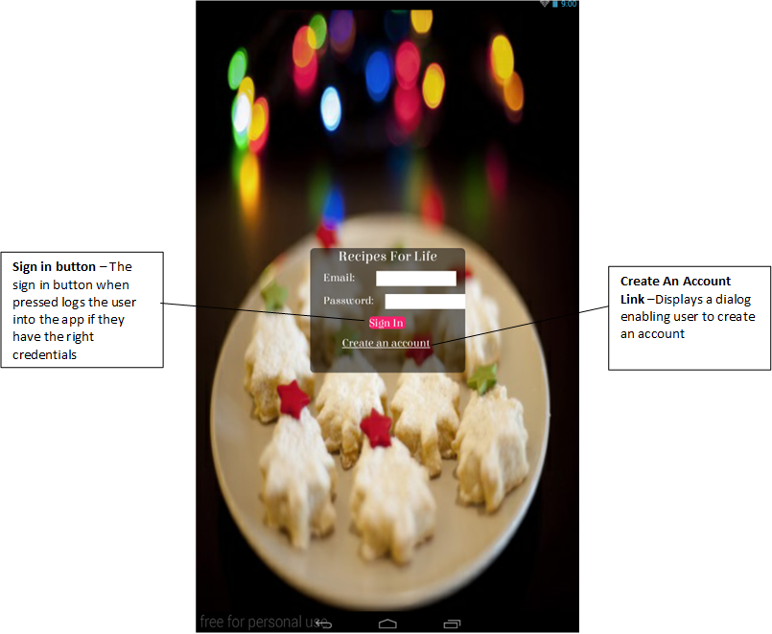

# Users Cookbook Screen

When the user is logged in to the application the first screen they will be shown is their cookbook shelf. If it is their first time in the application it will be an empty shelf. The shelf will contain the cookbooks they own and the cookbooks they are a part of.

**Cookbook Owner View**

If the user owns the cookbook they will see 3 icons next to the cookbook - a pen and paper icon, a user icon and a dustbin icon. This enables the owner to edit and delete the cookbook as well as manage contributors.

**Cookbook Contributor View**

If the user is a contributor to a cookbook they will only see the user icon next to the cookbook image. This enables the user to view the contributors in the book.

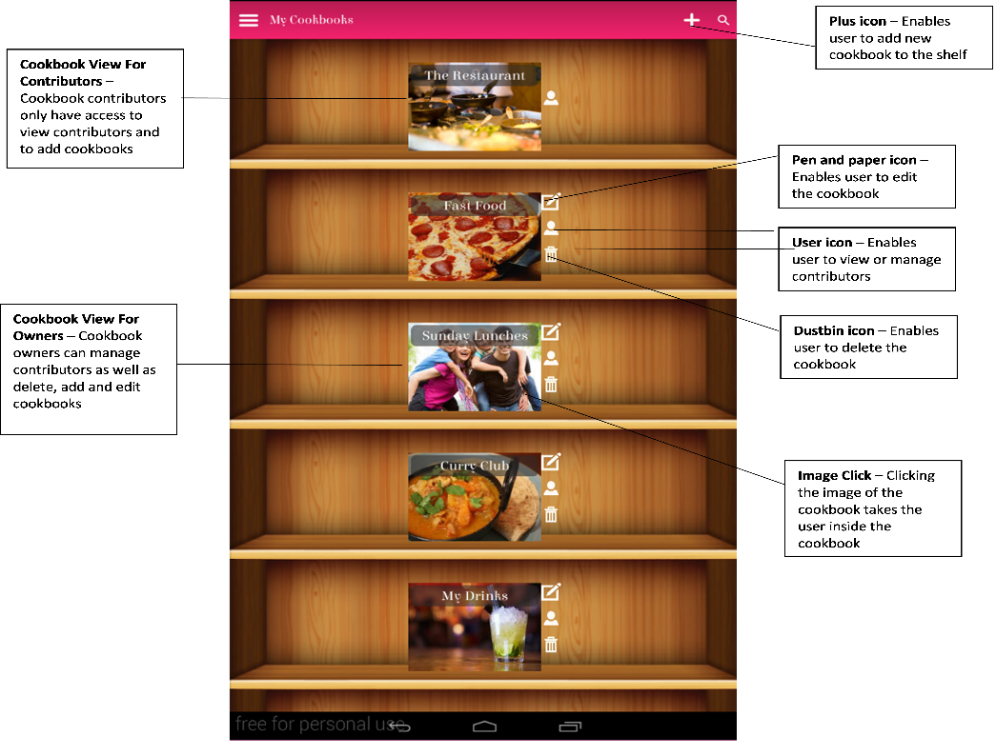

# Users Recipe Shelf

If the user clicks the cookbook image it will take them to the recipe shelf. This is a shelf of the recipes contained within the cookbook. The user is able to edit and delete recipes in the book as well as add new recipes to the book. The user can also copy any recipes they own into the shelf under a new name.

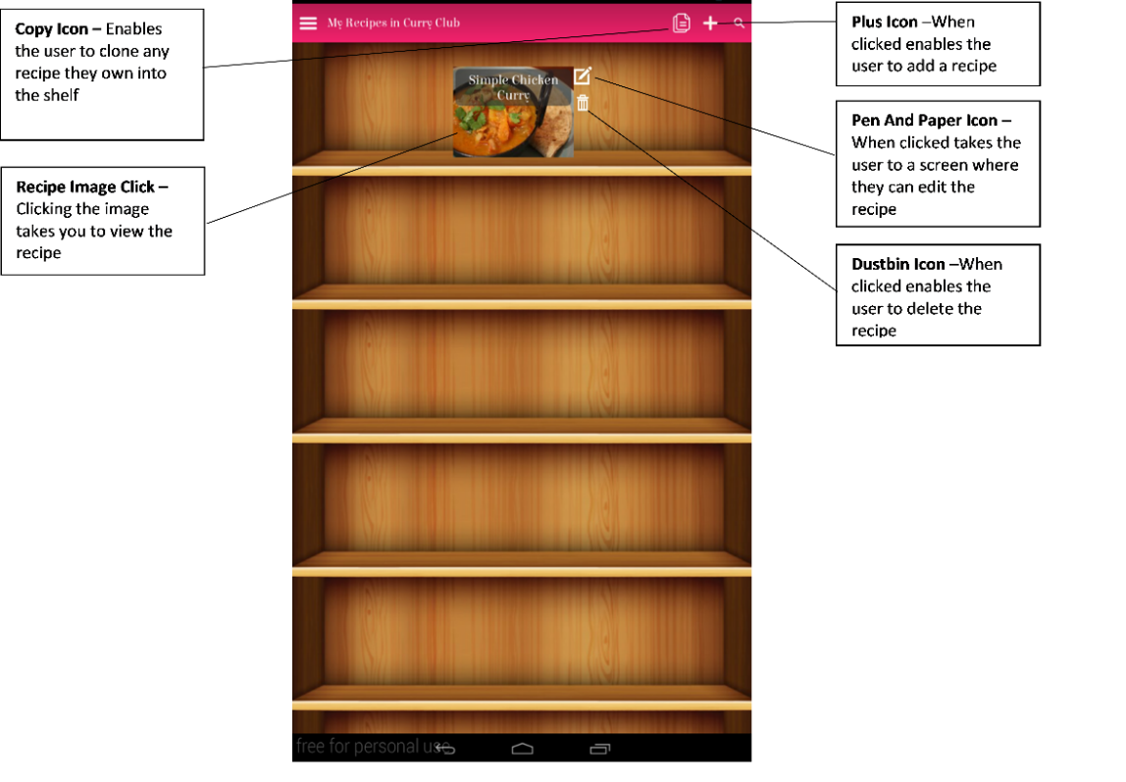

# Viewing A Recipe Screen

If the user clicks on the recipe image it will take them to the recipe view page which displays the recipe. It outlines the ingredients and steps in the recipe as well as its dietary requirements, prep/cooking times etc. At the bottom of the recipe any user can add comments, reviews or alterations which help to create collaboration. On the action bar at the top several icons are there to help improve viewing the recipe. These can be seen in the image below.

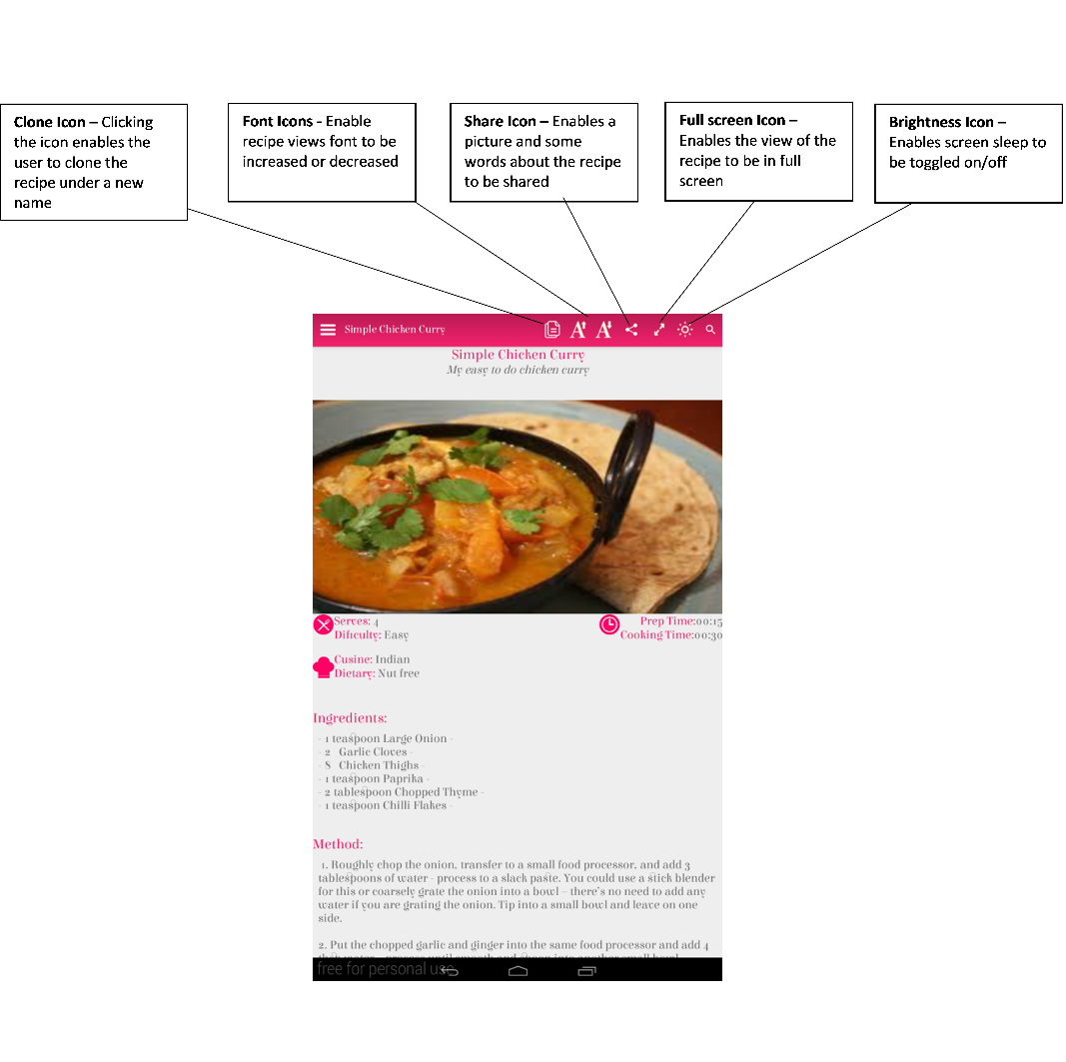

# Editing A Recipe Screen

In the recipe shelf if the user clicks the pen and paper icon it will take them to a page where they can edit the recipe. It looks similar to the recipe view but has pen and paper icons at different sections of the recipe which when clicked enables the user to edit that part of the recipe. At the bottom of the page there is a save button where the user can save the changes to the recipe. The user is also reminded to save before they leave the page.

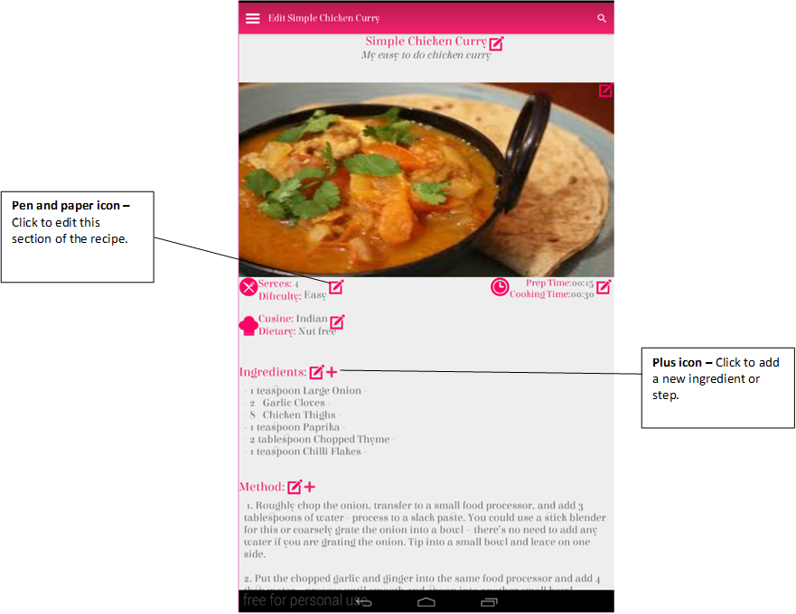

# Recipe Search Screens

In every screen in the app a search icon can be seen in the right hand corner of the action bar. When clicked this enables the user to input a query. The app searches for recipes, cookbooks or users that contain this query and then output the results in a results page.

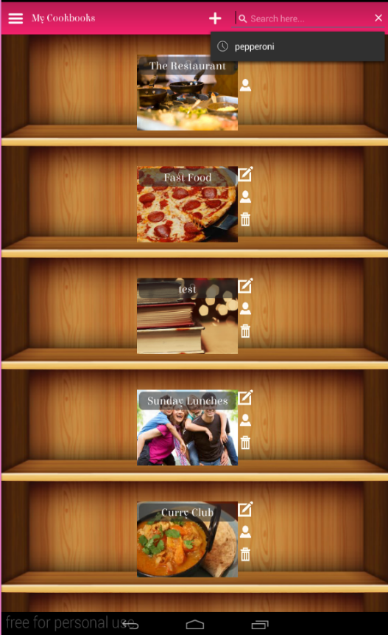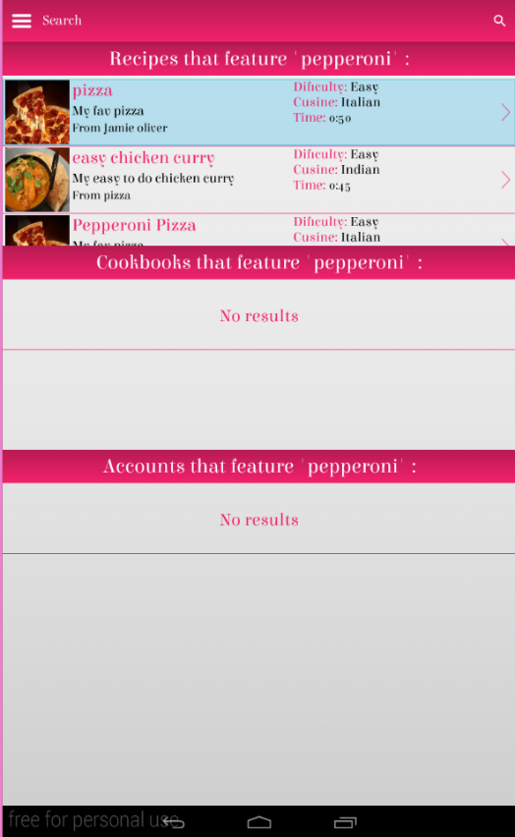

# Navigation Bar

In every screen in the app on the left hand side in the action bar is a menu icon which when clicked shows a navigation bar. This bar enables the user to return to the homepage, explore for new recipes or log out of the application.

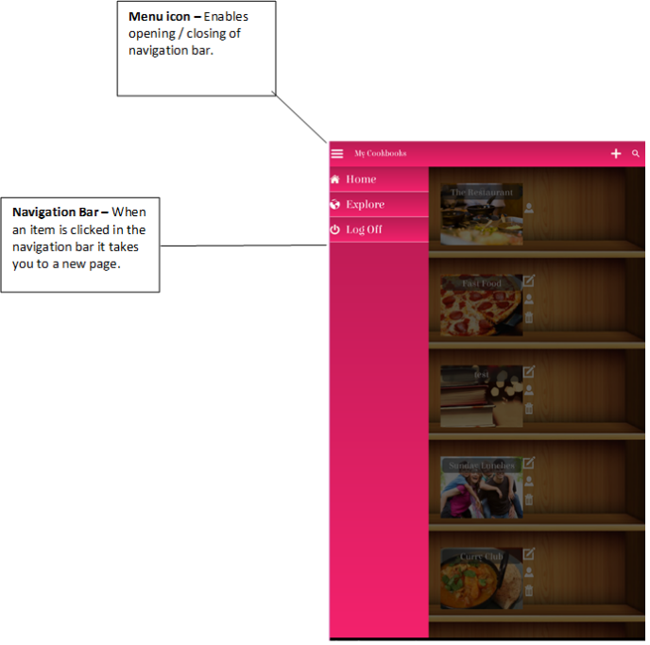

# Recipe Explore Screens

In the navigation bar there is an option called explore. When clicked this displays the option to find recipes by difficulty, cuisine or dietary requirements or to find cookbooks. When an option is clicked it will display a results page showing a selection of recipes or cookbooks that fit the requirements.

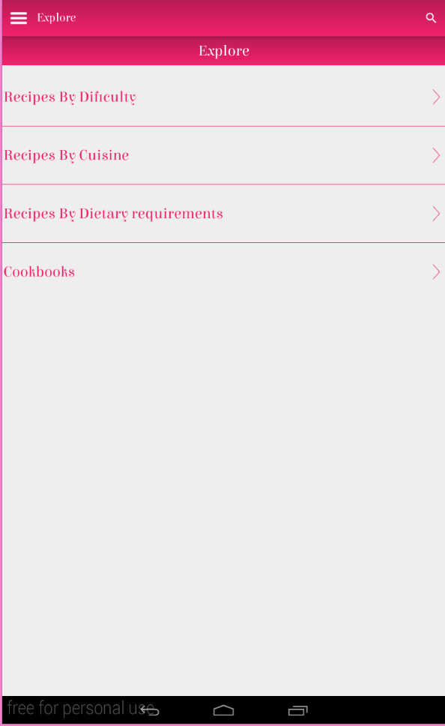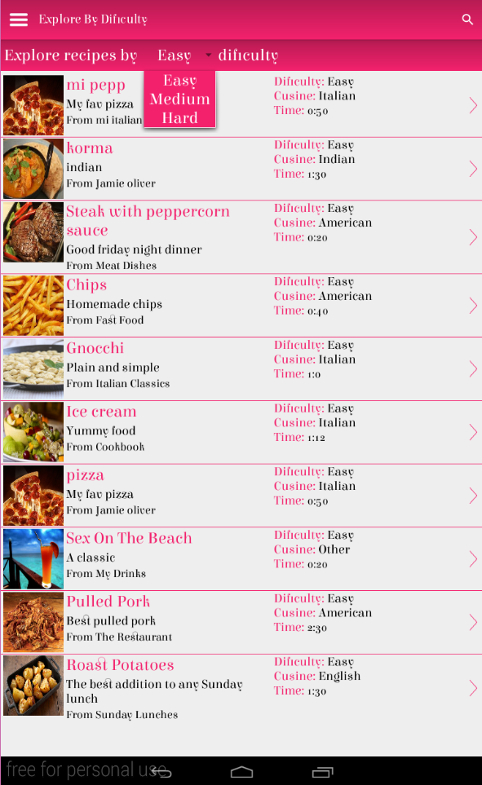

**Contact Details**

If you would like more information on Recipes For Life please contact Kari McMahon.

**Email:** [kmc_xo@hotmail.co.uk](mailto:kmc_xo@hotmail.co.uk)

**LinkedIn:** https://uk.linkedin.com/pub/kari-mcmahon/4b/826/645